Freedom and Equality Education Grant
2020 – 2021 Proposal Form
(The form should be submitted three weeks prior to date of event)
Maximum award is $500.00

Name:

Signature:

Organization:

Current Address:

PROJECT TITLE:

Total Amount Requested:

Date of Project:

_________________________________________________
Signature of UMW Club/Organization President Sponsor

_________________________________________________
Date:

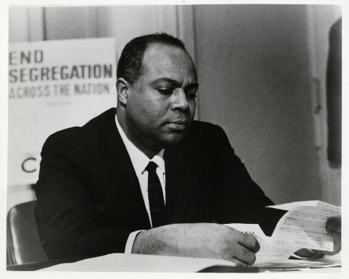

James Farmer Multicultural Center
Funding Proposal
A. STATEMENT OF OBJECTIVES

B. DESCRIPTION OF THE PROJECT (Max. 250 words)

C. RELATIONSHIP TO James Farmer Multicultural Center’s MISSION and ASPIRE Values (The JFMC strives to facilitate students’ learning and personal development, including that of underrepresented groups, by increasing students’ awareness and knowledge of diversity issues (i.e., cultural, ethnic, intellectual and social) that frame both the individual and the community. We create educational environments that broaden our understanding and appreciation of multiculturalism, diversity, and social justice. We also provide programs and services and activities to increase the awareness of Dr. Farmer’s legacy and contributions to society.)

D: INDIVIDUALS, ORGANIZATIONS, AND THEIR ROLES with the project

E. BUDGET (Please list itemized amounts, e.g., honorarium fee, quotes from vendors for supplies, technology, promotional materials, etc.)

F. Attachments (Please attached any documentation of expenses related to this proposal, e.g., quotes from vendors, etc.)

I agree to implement this program as it is outlined in this proposal. I also agree to submit a one-page summary within two weeks after the program. This summary report should include an assessment of the event and the number of attendees.

_________________________________________________
Signature:

_________________________________________________
Date:

If you have questions regarding this form, please contact Dr. Marion Sanford, Director of the JFMC, at 540-654-1044 or msanford@umw.edu. Please submit this form to the JFMC at the University Center, Room 319 or at jfmc@mail.umw.edu.

