**Vendor Information**

Craft and non-profit vendors are e located in Chandler Ballroom in the University Center. Food vendors are located in Ball Circle. In case of severe inclement weather, the craft and non-profit vendors will relocate to Chandler Ballroom in the University Center and entertainment will move to various locations (see program). The food vendors will remain on Ball Circle.

**General Information**

Should you need assistance during the day, the Information Table at the reception desk on the second floor of the University Center. Volunteers will be available throughout the fairgrounds and can be identified by their white Multicultural Fair t-shirts. Staff members can be identified by their blue t-shirts.

**Acknowledgements**

Special thanks to the Multicultural Fair Planning Committee, student volunteers, SAE, the Offices of Student Life and Student Involvement, UMW Media and Public Relations, UMW Police and Facilities Services. For more information concerning events coordinated by the James Farmer Multicultural Center, please visit our website at www.umw.edu/multicultural.

**Corporate Sponsor**

Wegmans

**Look for your posts/photos with #UMWMultiFair**

Facebook: UMW Multicultural Fair or UMW James Farmer Multicultural Center

Twitter: @UMWMultiCenter

“DIFFERENCES ENRICH US ALL”

cAnn

# 26th ANNUAL

# MULTICULTURAL FAIR

SATURDAY, APRIL 9, 2016

10:00 a.m. – 5:00 p.m.

UMW Fredericksburg Campus

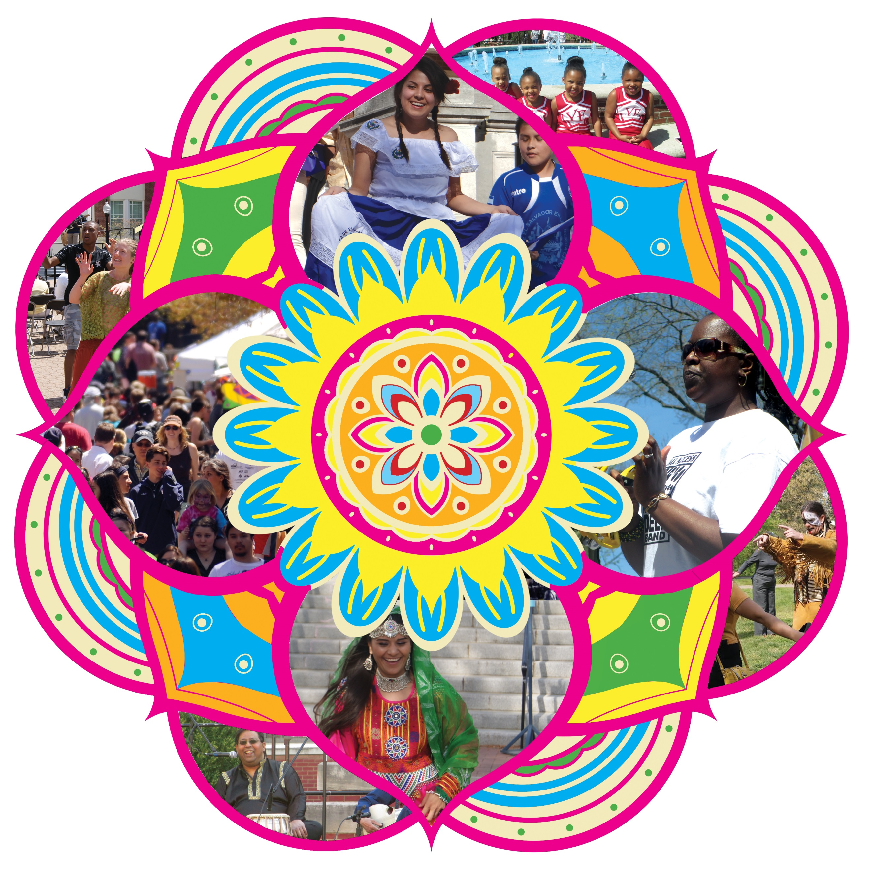

**Dodd Auditorium, George Washington Hall**

10:00-10:15 AM UMW Praise Dance

10:30-11:00 AM Calico Cloggers

11:15-11:45 AM Muggivan School of Irish Dance

12:15-1:00 PM Wylder Indie Pop Band

1:30-2:15 PM Ras Lidj & Deep Band- Reggae/Go-Go 2:45-3:30 PM Sunny Mountain Serenader- Appalachian Music

4:00-4:45 PM Sons of Solomon- Reggae Band

**Talon Lounge, University Center (formerly Monroe Stage- Children’s Area)**

11:00-11:45 AM Cody& BJ Interactive Music Show 12:15-1:00 PM Kim & Jimbo Cary Interactive World Music

1:30-2:00 PM Winding Creek Elementary African Ensemble

2:30-2:45 PM JNJ Dance Expressions Afro Jazz Dance

3:15-3:45 PM Rappahannock Area Kids on the Block Acceptance and Awareness Puppet Theatre

4:10-4:30 PM Aikido of Fredericksburg Martial Arts Demonstration

4:30-5:00 PM Tai Yim Kung Fu School Chinese Lion Dance

**Bathroom facilities are located in the following buildings:**

LEE HALL* MONROE HALL * UNIVERSITY CENTER* GEORGE WASHINGTON HALL* TRINKLE HALL

Additional Activities – Located University Center

**10:00 AM - 5:00 PM**

**Picasso Face & Body Painting – University Center, 2nd floor**

**1:00 – 3:00 PM - Lipsology (reading of lip prints) by Ariana Lightningstorm, Certified Lipsologist – University Center, 3rd floor**

**Children’s Area Activities**

Sponsored by UMW Student Clubs -10:00 AM – 5:00 PM

Located in University Center, room 303A- Student Activities Office

* **Asian Student Association** Paper Cutting & Coloring
* **Black Student Association** Paper Bag Crafts & Balloon Animals
* **Diversability** Braille Craft
* **Dorsey Scholars** Paper Bag Animal Crafts
* **Jewish Student Association/Hillel** Face Painting
* **PRISM**  Rainbow Craft
* **Women of Color** Cookie decorating

**Monroe Hall, room 116 (formerly Lee Stage)**

10:00-10:15 AM UMW Breakers

10:30-10:50 AM Native American Dancing 11:00-11:05 AM Afrobeat African Pop Dance

11:10-11:15 AM Bollywood Dance

11:20-11:25 AM Kpop Dance Korean Pop Dance

11:30-11:35 AM Hindi Steez Indian Pop/Bollywood Dance

11:45 AM-12:15 PM PRISM Dancers Middle Eastern Dance

12:45-1:30 PM LOW’n’BROWS Traditional German Music

2:00-2:25 PM Pilipino American Cultural Arts Society Philippine Traditional Dance

2:35-2:40 PM Eagle Bhangra Punjabi Folk Dance

3:00-3:30 PM Orfeia Vocal Ensemble Eastern European/Balkan Choir

3:45 – 3:50 PM UMW Middle Eastern Dance Club

4:00-4:10 PM UMW Alter Egos Stepping

4:30-5:00 PM Carolina Palaez Alternative Pop Singer

**Lee Hall, Underground (formerly Trinkle Stage)**

10:00-10:45 AM Harry Wilson Quartet

11:30-12:00 PM Cool McFinn- Celtic Music

12:45-1:30 PM *Comunidad Cultural Sur Andes* Traditional Bolivian Music and Dance

1:45-1:55 PM BellACappella UMW all female a cappella singing group

2:30-3:15 PM Anthony “Swamp Dog” Clark Blues/Funk

4:00-4:45 PM Prem Raja Mahat of Nepal Traditional Nepali Folk Music