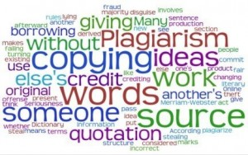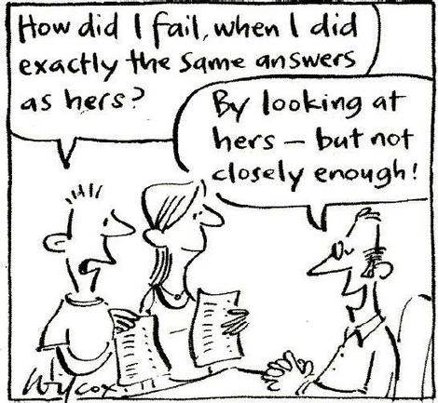

**Cheating Statistics**

* Cheating typically begins in middle school.
* Nine out of ten middle school students admit to copying someone else’s homework; two-thirds say they have cheated on exams.
* Cheating most often occurs in science and math classes.
* The college students who are most likely to cheat are engineering and business majors.

*(Source:* *http://academicintegrity.org)*

# Cheating to Pass or Cheating to Get Ahead?

## Back in 1940, only 20% of college students admitted to cheating during their academic careers. Today, that number has increased to 75% to 98%.

**75 to 98% of College Students Have Cheated**

Think about a time when you may have chosen to not follow your own personal honor code. What was the context? Why did you make the decision(s) you did? What was the outcome of that action? What similar scenarios might you imagine?

Reflection

Lee Hall, Room 412 11:00 a.m. -1:00p.m

**Cheating is Not OK; Fostering Integrity at UMW Faculty Workshop**

Co-sponsored by the Writing Center, Center for Teaching Excellence and the Center for Honor, Leadership, and Service

January 16, 2013

Integrity and Honor

* **Stress the importance of Integrity to the Learning Process.**
* **Highlight UMW’s Code of Academic Conduct**
* **Discuss issues of integrity**
* **Enlist students’ help in creating a climate of integrity in your class.**
* **Inspire, encourage, and model integrity.**
* **Set Clear standards**
* **Reflection Point:** In what ways, do you talk about academic integrity with your students?
* **Post-it Note Exercise:** Using the Post-it notes provided, write one example (per post-it note) of how you address academic integrity with your students. Place on the large poster paper.
* **Faculty and Post-it Note Sharing:** A few faculty will volunteer to share their experiences.
* **Building An Integrity Bridge:**

“Letter to My Students”

Integrity Scenario

Promoting Academic Integrity

10 Principles of Academic Integrity for Faculty

Source: University of California Davis (1999)

1) Affirm the importance of academic integrity.

2) Foster a love of learning.

3) Treat students as ends in themselves.

4) Foster an environment of trust in the classroom.

5) Encourage student responsibilities for academic integrity.

6) Clarify expectations for students.

7) Develop fair and relevant forms of assessment.

8) Reduce opportunities to engage in academic dishonesty.

9) Challenge academic dishonesty when it occurs.

10) Help define and support campus-wide academic integrity standards.

Source: Center for Academic Integrity. These “Ten Principles” first appeared as “Faculty and Academic Integrity” in the Summer 1997 issue of *Synthesis: Law and Policy in Higher Education*, Gary Pavela, editor.

### Academic Integrity: Building Bridges

#### Proactive by Curriculum Design

Illustration: Cathy Wilcox

* **Creating plagiarism-proof assignments**

* **Assignment Design**

* **Assignment Types/Variety**

* **Enlisting students to help create assignments**

* **What to do when plagiarism occurs**
* Educate students about plagiarism.
* Discuss the benefits of citing sources.
* Make penalties clear.
* Look for clues.
* Know where the sources of papers are.
* Search for the paper online.
* Have students sign the Honor Code.
* Prohibit talking or any communication.
* Number exams.
* Use a sign-in sheet for each row, by exam numbers, to record where students sit.
* Tell students not to leave the room.
* Have students sign each page of the exam in ink.
* Require written excuses for make-ups or extensions, and check authenticity
* Encourage students to sit away from study partners or friends during exams and to cover their work.
* By specifying details of source usage, you can make it hard to find a purchased or copied paper that won’t require substantial extra work on the students’ part.

Adapted from Seri Randolph (2004) , The Writing

Workshop.

Strategies of Prevention

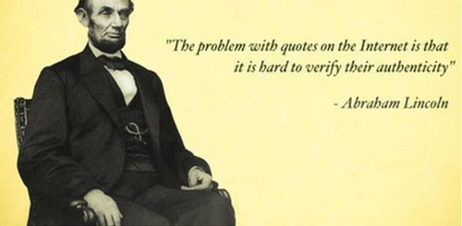

**Center for Academic Integrity**

<http://www.academicintegrity.org/icai/home.php>

**UMW Writing Center**

<http://academics.umw.edu/writing-fredericksburg/about-the-writing-center/>

<http://academics.umw.edu/writing-stafford/>

**Developing Assignments that Can’t Be Plagiarized: Some Ideas**

<http://www.gac.edu/oncampus/academics/library/plagiarism/assignments.html>

**Plagiarism-Proofing Your Assignments: Strategies, Suggestions, and Resources on the Web**

<http://abacus.bates.edu/cbb/docs/rudolph.pdf>

#### On-line Resources

* Assign narrow and specific research topics.
* Don’t allow last-minute change of topic.
* Clearly explain expectations. Require outlines be submitted 3-4 weeks prior to the deadline. Have drafts submitted with the final paper.
* Give written and/or oral quizzes in class.
* Require detailed citations, including page numbers. Encourage students to come to you if unsure about citation practices.
* Add UMW’s Honor Code on your syllabus. Talk about academic honesty with your students and make sure they understand both the reasons and the tools for avoiding plagiarism.
* Be a good role model. Cite sources in your lectures. Talk to students about how citation shows respect for other scholars.

Adapted from Cole, S. & Kiss, E. (2000).“What Can We Do About Student Cheating?” *About Campus*, May-

June.

Tips for Discouraging Plagiarism